
Lab Program Number: 04 Date: 2025-07-04
Title: Static IP Setting on Windows/Linux Machine Using GUI and Command Prompt

Theory:
IP Address (Internet Protocol Address):
An IP address, or Internet Protocol address, is a unique numerical identifier assigned to every device connected to a computer network that uses the Internet Protocol for communication. Think of it like a postal address for your computer, allowing data to be sent and received across the internet. IP addresses enable devices to locate and communicate with each other, ensuring that information reaches its intended destination. They are essential for routing data packets and are a fundamental part of how the internet functions. There are two main types of IP addresses: Static IP Address and Dynamic IP Address.

- Static IP Address
A static IP address is an IP address that is manually configured and remains constant over time. It does not change unless manually reconfigured. This type of address is generally used in systems where consistent addressing is required, such as servers or networked hardware.

- Dynamic IP Address
A dynamic IP address is automatically assigned by a DHCP (Dynamic Host Configuration Protocol) server. It can change periodically, typically each time the device connects to the network. Dynamic addressing is commonly used in networks where devices frequently join or leave the network.

Subnet Mask
A subnet mask is a 32-bit number that divides an IP address into network and host portions, enabling efficient network routing. It acts like a filter, telling devices how to interpret an IP address and whether a destination is on the same local network or a remote one. By separating the network and host portions, subnet masks allow for the creation of smaller, more manageable subnets, improving network performance and organization.
Example: Subnet Mask: 255.255.255.0

Default Gateway
A default gateway acts as a router, enabling communication between devices on a local network and external networks, like the internet. It's the designated exit point for a network, directing traffic to its destination when the destination is not within the same network segment. Essentially, it's the address a computer uses as a default route to reach other networks. Without a default gateway, devices on different networks wouldn't be able to communicate with each other or access the internet.
Example: Default Gateway: 192.168.1.1

DNS Server (Domain Name System Server)
A DNS Server is responsible for translating human-friendly domain names (like www.example.com) into IP addresses that computers use to identify each other on the network. When you type a website address into your browser, the DNS server looks up the corresponding IP address so that your request can be routed to the correct server. DNS servers are essential for the usability of the internet, as they allow users to navigate online using easy-to-remember names rather than complex numeric IP addresses.
Example: DNS Server 8.8.8.8 (Google’s public DNS server).

Static IP
A Static IP is a fixed IP address manually assigned to a device. It does not change over time, making it ideal for services that need consistent access, such as web servers, printers, and remote access systems.
Static IPs are reliable for hosting and easier to locate, but they can be more vulnerable to attacks since the address is always the same.
Example:
Static IP: 192.168.1.10

Benefits of Static IP
- Consistent Network Address: The IP address doesn’t change, making it easier to manage and locate the device on a network.
- Reliable for Hosting: Ideal for servers, websites, FTP, and email hosting, as they require a fixed address.
- Easier Remote Access: Devices with static IPs can be accessed remotely without IP changes, useful for remote desktop or VPN connections.

- Changing Static IP Configuration using GUI
Step 1: Network Information
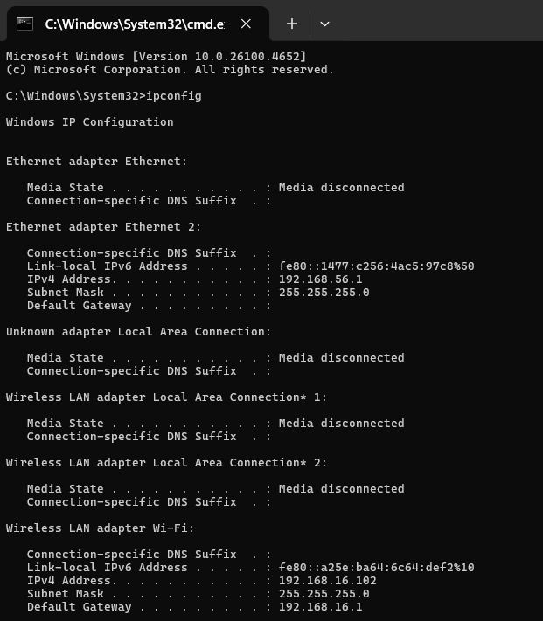

Fig: Default network information

Step 2: Using the ‘ping’ command to verify network connectivity on the default network connection by testing responses from the gateway and external websites.
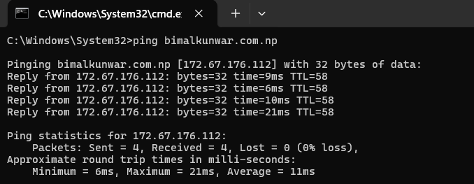

Fig: Network Connectivity of bimalkunwar Server

Step 3: Access Network and Sharing Center
1.1 Go to Start Menu → open Control Panel
1.2 Click on Network and Internet, then select Network and Sharing Center
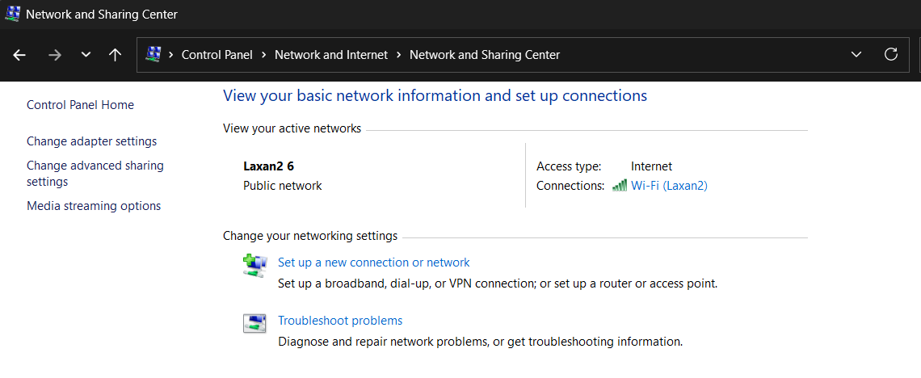

Fig: Network and Sharing Center in control panel

Step 4: Open Adapter Settings
2.1 In the left sidebar, click on "Change adapter settings"
2.2 Right-click on your active network connection and choose "Properties"

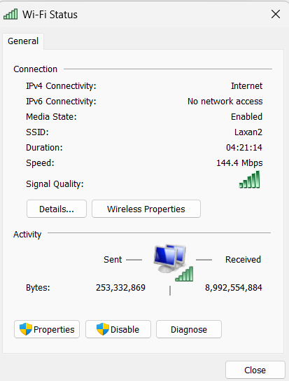

Fig: Network Selection on Adapter Settings

Step 5: Configure IPv4 Settings
3.1 Select Internet Protocol Version 4 (TCP/IPv4) and click Properties.
3.2 Choose User the following IP address and input the following details:
IP Address: 195.168.1.100
Subnet Address: 255.255.255.0
Default Gateway: 195.168.1.1
3.3 Enter the DNS Server address
Preferred DNS Server: 8.8.8.8
Alternate DNS Server: 8.8.4.4
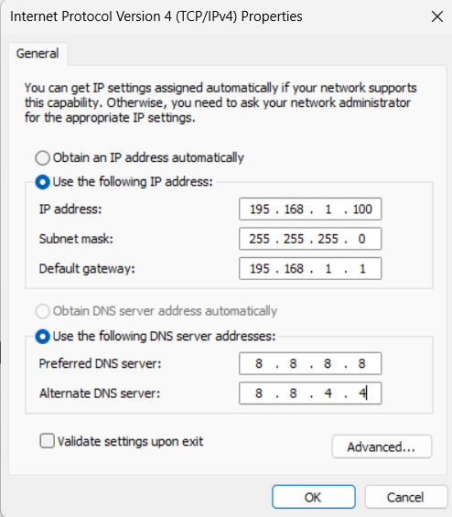

Fig: Configuring IPv4 Properties

Step 6: Save and Verify
4.1 Click OK to apply and save the settings
4.2 Execute ‘ipconfig’ command in command prompt to verify that the static IP address is configured correctly.
Network Information After Static IP Configuration using GUI
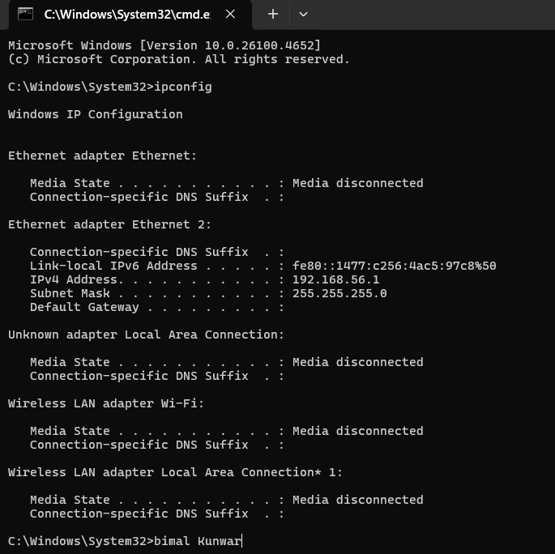

Fig: Network Information After Static IP Configuration

Verifying network connectivity after configuring a static IP by using the ‘ping’ command to check responses from the gateway and external websites.
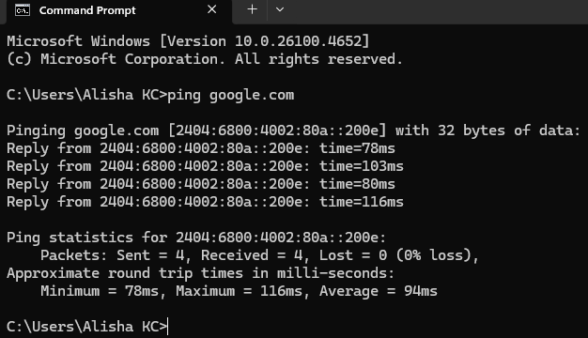

Fig: Network Connectivity of Google’s Server

Changing Static IP Configuration using Command Prompt
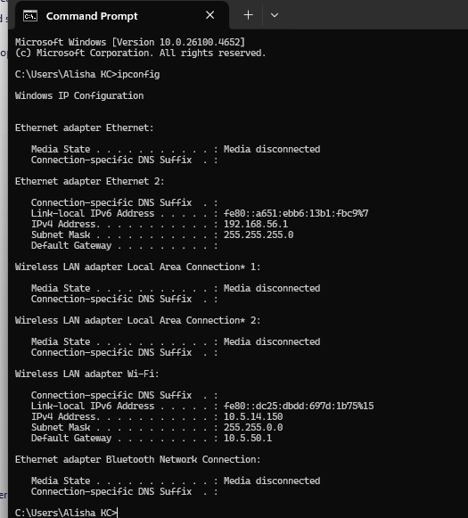
Step 1: Network Information.

Fig: Default network information

Step 2: Using the ‘ping’ command to verify network connectivity on the default network connection by testing responses from the gateway and external websites.
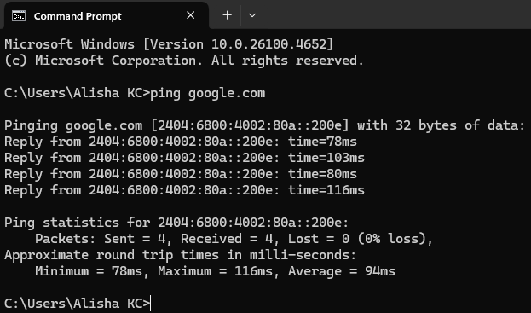

Fig: Network Connectivity of Google’s Server
Step 3: Search and Open Command Prompt
1.1 Click on the Search bar
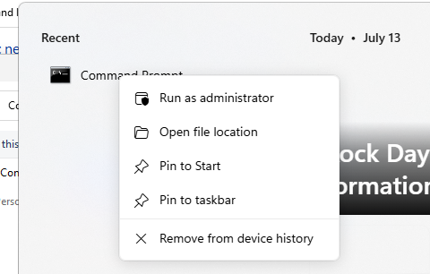
1.2 Type Command Prompt, then right-click it and select Run as administrator.

Fig: Launching Command Prompt via Search Bar as Administrator

Step 4: Get Network Interface Name
2.1 In the Command Prompt, type the following command and press Enter:
Syntax: netsh interface ipv4 show interface
2.2 Identify the exact name of the active interface (e.g., "Wi-Fi" or "Ethernet") to be used in the upcoming static IP configuration.
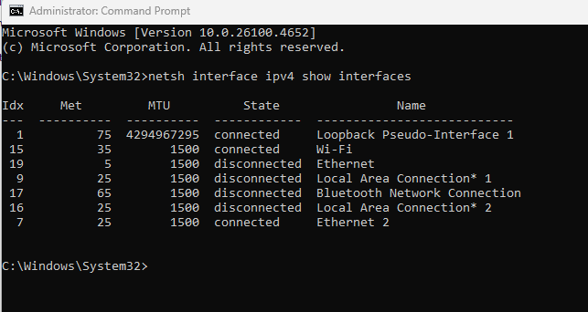

Fig: Network Interfaces Listed Using netsh Command

Step 5: Set Static IP Address
3.1 Use the following command to assign a static IP address to the network interface:
Syntax: netsh interface ipv4 set address name=" Ethernet 2" static 195.168.1.100 255.255.255.0 195.168.1.1
Here,
195.168.1.100 → Desired static IP address
255.255.255.0 → Subnet mask
195.168.1.1 → Default gateway
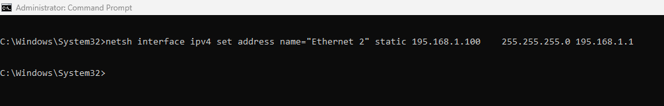

Fig: Setting Static IP Using netsh Command

Step 6: Set DNS Server
4.1 Assign the preferred DNS server with this command:
Syntax: netsh interface ipv4 set dns name="Ethernet 2" static 8.8.8.8
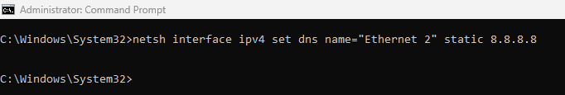
netsh interface ipv4 add dns name="Ethernet 2" 8.8.4.4 index=2
Fig: Setting Preferred DNS Server Using netsh Command
Fig: Setting Alternate DNS Server Using netsh Command

Network Information After Static IP Configuration using Command Prompt
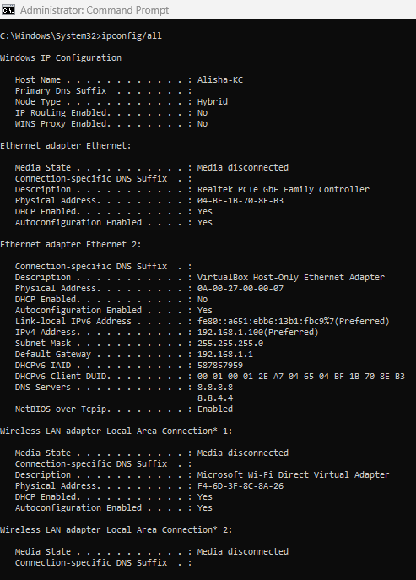
Network Information:

Fig: Network Information After Static IP Configuration

Verifying network connectivity after configuring a static IP by using the ‘ping’ command to check responses from the gateway and external websites.
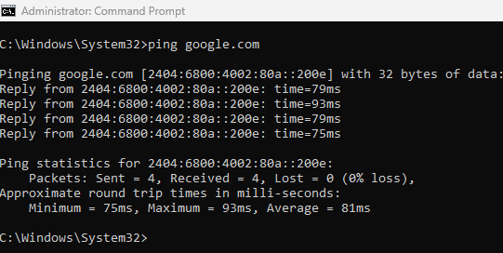

Fig: Network Connectivity of Google’s Server

Conclusion:
In this lab, we effectively set up static IP addresses on both Linux and Windows systems. Static Ips are essential for ensuring stable network communication, particularly for devices that offer services needing a fixed address. The lab provided a thorough demonstration of how to configure and verify static IP settings, enhancing our grasp of network configuration processes. By practicing these steps, we gained valuable experience in managing network settings, which is crucial for troubleshooting and optimizing network performance in real-world scenarios. This hands-on approach reinforced our understanding of how static IPs contribute to network reliability and consistency.

